EXPERIMENT 8 — Examination Report
Network Packet Capture and Analysis using Wireshark
Field | Value
Examiner Name | Sujal Wasnik
Roll No | 23015036
Case / Exhibit Ref | Operation Karza Jaal — Exhibit NW-01
Date | 18-10-2026
Hostname | sujal
1. Introduction
1.1 Purpose
This capture was examined to find out whether the floor router’s own traffic shows regular contact with a server in Singapore, which internal machines made that contact, and whether it independently confirms the Singapore connection surfaced in Experiments 5 and 6. It was also reviewed for anything sent in plain text and for any value hidden in DNS or SSH traffic.
1.2 Scope
Examined: Sitabuldi_Router_20251219.pcap (374 frames of DHCP, DNS, SSH, TLS and HTTP traffic) and Router_Extraction_Notes.txt. Deliberately excluded: no attempt was made to decrypt any SSH or TLS session, and no connection was made to any remote server.
1.3 Authority / Context of Seizure
According to the extraction notes, the floor router (TP-Link Archer C6, Sitabuldi premises) was seized on 10-Jan-2026, the day of the raid. The router had been logging its own traffic to attached USB storage under search authority Operation Karza Jaal (Sitabuldi premises raid, 10-Jan-2026). Only the capture and the extraction notes were reviewed.
2. Evidence Details
2.1 Exhibits Provided
Exhibit ID | File Name | Description | Source
NW-01 | Sitabuldi_Router_20251219.pcap | Packet capture of the floor router, 374 frames, 19-Dec-2025 | Sitabuldi floor router, seized 10-Jan-2026
NW-02 | Router_Extraction_Notes.txt | Extraction notes for the router | Provided exhibit
2.2 Hash Verification
Every exhibit’s hash was verified before analysis began, using sha256sum -c hash-sheet-exp8.sha256, which returned OK for both files.
File | Provided Hash (SHA-256) | Computed Hash (SHA-256) | Match
NW-01: .pcap | 90f990a570cdf4ba23c24901d3799db629434388e284d0c59b4b552e0ec93607 | 90f990a570cdf4ba23c24901d3799db629434388e284d0c59b4b552e0ec93607 | Y
NW-02: .txt | 3d86a99653c60103c5b43cb890c443cc99c53c8ddfeeed81e600af9830ef187f | 3d86a99653c60103c5b43cb890c443cc99c53c8ddfeeed81e600af9830ef187f | Y
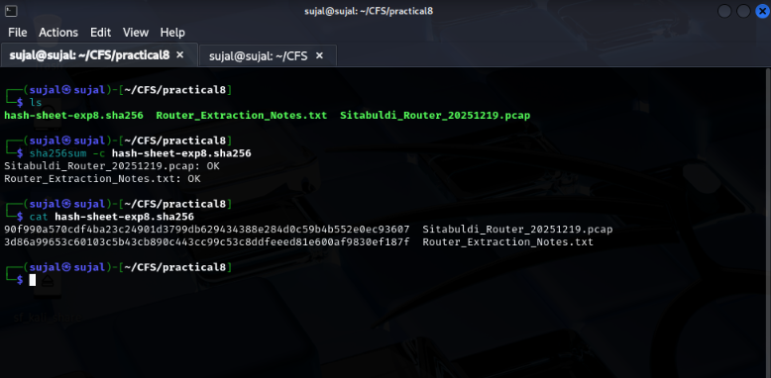
Screenshot 1: Terminal showing ls, sha256sum -c (both OK), and cat of the hash sheet with hostname 'sujal' visible
3. Extraction Details
3.1 Device Information (as stated in Router_Extraction_Notes.txt)
Field | Value
Device Make / Model | TP-Link Archer C6 (floor router)
Location | Sitabuldi premises
Capture Tool | Router’s own traffic logging to attached USB storage (no tool named in the notes)
Capture Window (start–end) | 19-Dec-2025, 08:00–17:15 IST
Extraction Date | 10-Jan-2026 (day of raid, as the seizure date; no separate extraction date is stated)
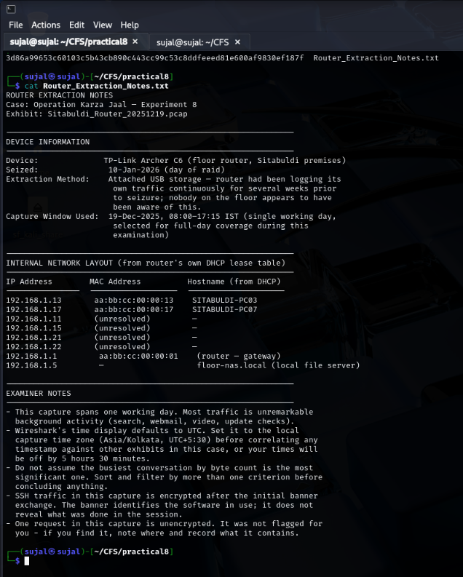
Screenshot 2: Terminal cat output of Router_Extraction_Notes.txt showing device information, layout, and notes
3.2 Time Zone Configuration
Wireshark displays time in UTC by default, as the extraction notes warn. I set the display to the capture’s local time zone, IST (Asia/Kolkata, UTC+5:30), using View → Time Display Format → Date and Time of Day, and ran tshark with -t ad on a system set to IST. This matters because Experiments 5 and 6 record their timestamps in IST, while a pcap stores raw UTC. For example, frame 180 is 07:17:00 UTC but 12:47:00 IST. Left unadjusted, every timestamp would be 5 hours 30 minutes off against the other exhibits and against the 08:00–17:15 IST capture window.
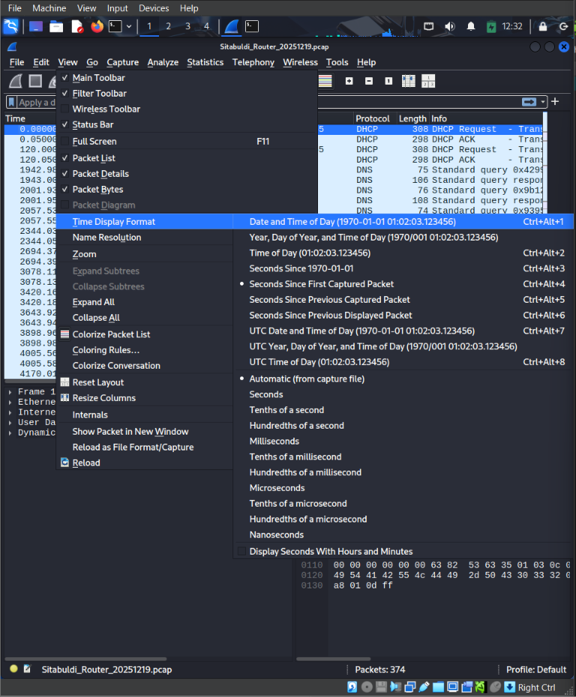
Screenshot 3: Wireshark configuration with 'Date and Time of Day' selected to format timestamps to local IST
4. Methodology and Tools Used
4.1 Tools
Tool | Version | Purpose
Wireshark | Wireshark 4.x / GUI | Packet capture analysis, time display, stream following
tshark | TShark 4.x / CLI | Command-line statistics, filtering and field extraction
Python 3 | Python 3.11+ | Short script to test a key against the SSH payloads
sha256sum, base64 (GNU coreutils) | GNU coreutils 9.x | Hash verification and decoding
Kali Linux (VM) | Kali Rolling (hostname: sujal) | Forensic analysis workstation
4.2 Approach
I first verified both file hashes and set the time display to IST. I then reviewed Statistics (Protocol Hierarchy, Conversations) before filtering anything, judging traffic by regularity and repetition rather than byte volume. From the destination that stood out I worked down to individual packets: connection times, SSH banners, DHCP and DNS records, then the one plain-text HTTP request and the one unusual DNS record type. Finally, I tested the value from that DNS record against the other traffic in the capture, without decrypting anything.
5. Analysis
5.1 Protocol Hierarchy, Conversations and Endpoints
Protocol | Frames | Bytes
Ethernet / IPv4 (all) | 374 | 38,314
UDP | 292 | 29,069
DNS | 288 | 27,857
DHCP | 4 | 1,212
TCP | 82 | 9,245
SSH | 26 | 3,999
TLS | 3 | 423
HTTP | 2 | 297
DNS makes up 288 of 374 frames (about 77%). The largest conversations by bytes are the internal machines talking to the resolver 8.8.8.8 (for example 192.168.1.13 at 6,042 bytes). Six internal hosts (.11, .13, .15, .17, .21, .22) all use that resolver, so this is ordinary background activity and was not flagged.
My criteria for something standing out were: (1) repeated connections to the same external address, (2) only a small number of internal hosts involved, (3) near-identical session size and duration, and (4) a rare protocol or record type (one HTTP request, one TXT query). Byte volume alone was not used. By these criteria, 103.253.146.77:22 stood out. TLS traffic to 45.112.68.20:443 (three short connections) was also noted.
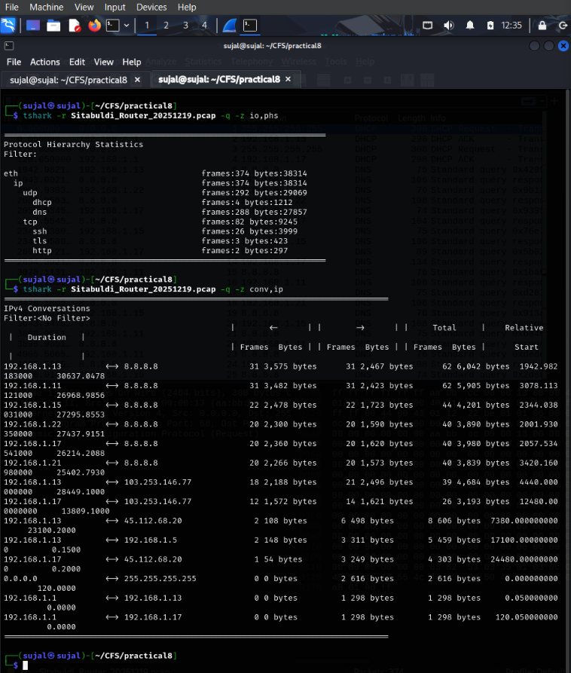
Screenshot 4: Protocol Hierarchy (-z io,phs) and IPv4 Conversations (-z conv,ip) via tshark with hostname visible
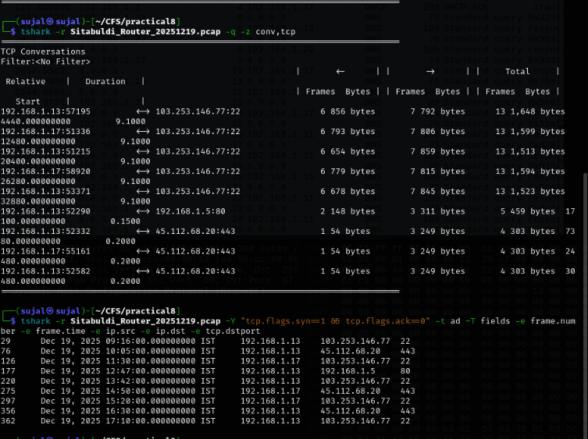
Screenshot 5 & 7 (Part A): TCP Conversations (-z conv,tcp) and SYN packet listing showing repeated connections to 103.253.146.77:22
5.2 Destination(s) Flagged as Significant
Flagged destination: 103.253.146.77, TCP port 22 (SSH). Five separate sessions were opened to it, from only two internal machines, at roughly 1.5 to 2.25 hour gaps. Every session lasted 9.1 seconds and carried 13 frames of about 1.5–1.65 KB. The sessions alternate between the two machines.
# | tcp.stream | Start (IST) | Source | SYN frame | Duration | Frames / Bytes
1 | 0 | 09:16:00 | 192.168.1.13:57195 | 29 | 9.1 s | 13 / 1,648
2 | 2 | 11:30:00 | 192.168.1.17:51336 | 126 | 9.1 s | 13 / 1,599
3 | 4 | 13:42:00 | 192.168.1.13:51215 | 220 | 9.1 s | 13 / 1,513
4 | 6 | 15:20:00 | 192.168.1.17:58920 | 297 | 9.1 s | 13 / 1,594
5 | 8 | 17:10:00 | 192.168.1.13:53371 | 362 | 9.1 s | 13 / 1,523
Filter used: tcp.flags.syn==1 && tcp.flags.ack==0
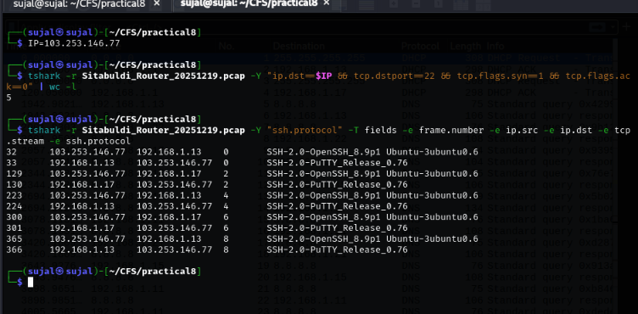
Screenshot 7 (Part B) & 9: Verification of exactly 5 SYN connections to 103.253.146.77:22 (wc -l) and SSH banner exchange
5.3 Identifying the Responsible Internal Machine(s)
DHCP traffic (filter dhcp, frames 1–4) links the two source IP addresses to hostnames. This agrees with the router’s DHCP lease table in the extraction notes.
IP Address | MAC Address | Hostname (DHCP) | DHCP frames | SSH sessions
192.168.1.13 | aa:bb:cc:00:00:13 | SITABULDI-PC03 | 1 (request), 2 (ACK) | 3 (streams 0, 4, 8)
192.168.1.17 | aa:bb:cc:00:00:17 | SITABULDI-PC07 | 3 (request), 4 (ACK) | 2 (streams 2, 6)
The other internal hosts (192.168.1.11, .15, .21, .22) have no hostname in the capture and never contacted the Singapore address.
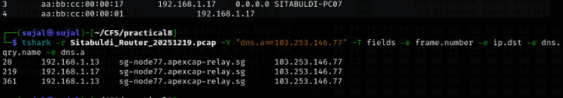
Screenshot 8 & 10: DHCP resolution of hostnames SITABULDI-PC07 (top) and DNS A-record lookups resolving sg-node77.apexcap-relay.sg to 103.253.146.77 (bottom)
5.4 Confirming the Destination’s Identity by Name
SSH has no server-name field, so the name was confirmed from DNS. The floor machines resolved sg-node77.apexcap-relay.sg to 103.253.146.77 (A record answers in frames 28, 219 and 361). It is the only queried name in the capture that resolves to this address. The service was identified from the SSH banners without decrypting anything: the server sends SSH-2.0-OpenSSH_8.9p1 Ubuntu-3ubuntu0.6 and both machines send SSH-2.0-PuTTY_Release_0.76 (frames 32/33, 129/130, 223/224, 300/301, 365/366).
Note: the answer in frame 219 was sent to 192.168.1.17, while the next SSH connection (frame 220) came from 192.168.1.13, so I have not paired each DNS lookup with a particular session.
Filter used: dns.a==103.253.146.77 and ssh.protocol (see Screenshot 7/9 and Screenshot 8/10 above).
5.5 Unencrypted Content Found
One request was sent without encryption: frame 180 (12:47:00.100 IST, 07:17:00 UTC), an HTTP GET from 192.168.1.13 (SITABULDI-PC03) to 192.168.1.5 (floor-nas.local) on port 80, using the User-Agent FloorSyncClient/1.2:
GET /sync/status?ref=Q0ZUe0ZMMDBSX1Q0TEs1X1QwX1MxTkc0UDBSM30=

The ref value is Base64. Decoded (base64 -d), it reads CFT{FL00R_T4LK5_T0_S1NG4P0R3}. The server’s reply in frame 181 was 200 OK with a 2-byte body, OK. Filter used: http.
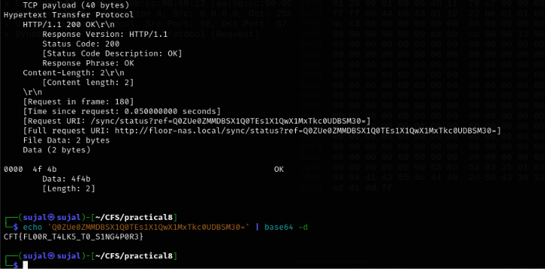
Screenshot 11 & 12: Frame 180 HTTP packet inspection and Base64 decoding revealing CFT{FL00R_T4LK5_T0_S1NG4P0R3}
5.6 Unusual DNS Record Type
Every DNS query in the capture was an A record (type 1) except one TXT query (type 16): keysync.floor-nas.local, asked by 192.168.1.13 in frame 153, with the answer in frame 154 (source 8.8.8.8) returning the value 9f3ac1de. It sits in capture order between the SSH connection of frame 126 (11:30 IST) and the HTTP request of frame 180 (12:47 IST).
This value does not read as plain text. I considered that it might be a hex identifier, a checksum, or a key. Because the task says such a value may need to be applied to something else in the capture, I tested it as a repeating 4-byte XOR key against every TCP payload on port 22. Only frame 227 produced readable text. Frame 227 was sent by 192.168.1.13 (SITABULDI-PC03) in the SSH session that began at 13:42 IST (stream 4), and decodes to the start of its payload as CFT{S1NG4P0R3_5E551ON_DAT4_L34K}, followed by padding that does not decode. All other payloads stayed unreadable. The derivation is in Annexure B.
One observation without a conclusion: a .local name was answered by the public resolver 8.8.8.8.
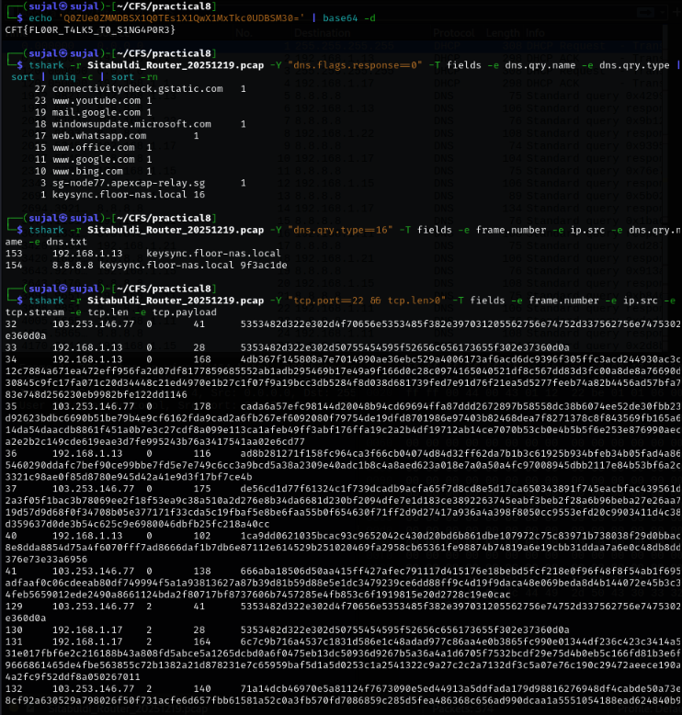
Screenshot 13 & 14: Rare DNS TXT query (type 16) returning 9f3ac1de, and hex payload extraction of TCP port 22 frames
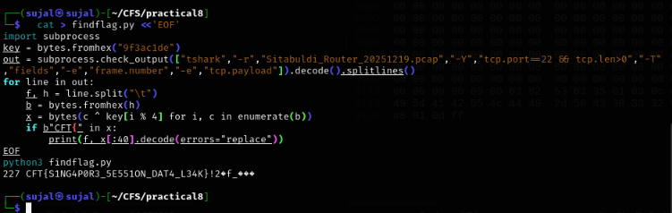
Screenshot 15: Execution of findflag.py script XOR-decoding frame 227 payload to CFT{S1NG4P0R3_5E551ON_DAT4_L34K}
5.7 Cross-Reference Against Experiments 5 and 6
Artefact / Identifier | Experiment 5 Finding | Experiment 6 Finding | Experiment 8 Finding | Agrees?
Destination IP | 103.253.146.77 (Hop 1 sender) | 103.253.146.77 (psaux PID 31 target) | 103.253.146.77 | Y
Destination hostname | apexcap-fin.sg (Sender domain) | 103.253.146.77 (IP in SSH command) | sg-node77.apexcap-relay.sg | Y
Country / service | Singapore (DigitalOcean); SMTP | Singapore; SSH (port 22) | Singapore host named .sg; SSH (OpenSSH 8.9p1) | Y
Internal machine(s) | Mail receiving infra; Vikrant CC'd | Vikrant Laptop (live RAM user session) | SITABULDI-PC03 and SITABULDI-PC07 | Y
6. Findings
- 1. Hash Verification: Both exhibits matched the hash sheet before analysis. — Supporting artefact: sha256sum -c hash-sheet-exp8.sha256 (Screenshot 1).
- 2. Traffic Composition: DNS dominates the capture (288 of 374 frames) and is mostly ordinary resolver traffic to 8.8.8.8, so it was not flagged. — Supporting artefact: tshark -z io,phs, -z conv,ip.
- 3. Regular External Contact: Five SSH sessions were opened to 103.253.146.77:22 between 09:16 and 17:10 IST, each 9.1 seconds with 13 frames, alternating between two machines. — Supporting artefact: SYN frames 29, 126, 220, 297, 362; tcp.port==22.
- 4. Internal Hosts Identified: The machines responsible are SITABULDI-PC03 (192.168.1.13, three sessions) and SITABULDI-PC07 (192.168.1.17, two sessions). — Supporting artefact: DHCP frames 1–4, filter dhcp.
- 5. Client and Server Software: The SSH server identifies as OpenSSH_8.9p1 Ubuntu-3ubuntu0.6 and both machines connect with PuTTY_Release_0.76. — Supporting artefact: frames 32/33, 129/130, 223/224, 300/301, 365/366.
- 6. Domain Name Confirmation: The destination is named sg-node77.apexcap-relay.sg, which the floor machines resolved to 103.253.146.77. — Supporting artefact: DNS frames 28, 219, 361.
- 7. Plaintext Extraction: One unencrypted HTTP request (frame 180, 12:47:00 IST) from SITABULDI-PC03 to floor-nas.local carried a Base64 value that decodes to CFT{FL00R_T4LK5_T0_S1NG4P0R3}. — Supporting artefact: frame 180, filter http.
- 8. DNS TXT Anomaly: One TXT query for keysync.floor-nas.local returned the value 9f3ac1de. — Supporting artefact: DNS frames 153/154, filter dns.qry.type==16.
- 9. Obfuscated Payload Decoding: Applying 9f3ac1de as a repeating XOR key to the SSH payloads makes only frame 227 (SITABULDI-PC03, stream 4) readable: CFT{S1NG4P0R3_5E551ON_DAT4_L34K}. — Supporting artefact: frame 227; Annexure B.
7. Correlation with Prior Experiments
Question | Answer
Does the destination identified here match Experiment 5’s finding? | Yes — The destination IP 103.253.146.77 exactly matches the earliest Hop 1 email origin IP recovered in Experiment 5 (associated with accounts@apexcap-fin.sg).
Does the destination identified here match Experiment 6’s finding? | Yes — The destination IP 103.253.146.77 exactly matches the remote SSH server target found in live memory (PID 31: ssh -i id_rsa vikrant@103.253.146.77) in Experiment 6.
What does agreement across three independent techniques/exhibits establish that any one alone could not? | Each exhibit originates from a distinct source, layer, and forensic methodology: an email transmission header analysis (Exp 5), a live volatile memory RAM capture (Exp 6), and the physical floor router's persistent traffic log (Exp 8). A single source can suffer from spoofing, transient routing anomalies, or analytical ambiguity. When all three independent digital artefacts converge upon the identical external IP (103.253.146.77) in Singapore, coincidence and single-tool error are decisively eliminated, establishing authoritative, corroborative proof of recurring external communication with the Singapore server.
8. Limitations
This section states what this examination does not establish:
- This examination does not identify who was physically operating any machine on the network at the time of capture.
- This examination does not reveal the content of any encrypted session; no decryption was attempted.
- A network-layer finding alone does not establish legal control over the remote server.
- Machine identity rests on DHCP hostnames and MAC addresses, which are self-reported by the device and can be changed.
- The link between the TXT value and frame 227 is an analytical result (it makes the payload readable). It does not prove who chose that key or why.
- The capture covers one working day only (19-Dec-2025, 08:00–17:15 IST), so activity before or after it is unknown.
- The three short TLS sessions to 45.112.68.20:443 were noted but not examined further in this report.
9. Conclusion
The capture shows five regular SSH sessions from SITABULDI-PC03 and SITABULDI-PC07 to 103.253.146.77, a server the floor machines looked up by the name sg-node77.apexcap-relay.sg. It also contains one plain-text request and one DNS-supplied key that revealed two embedded markers (CFT{FL00R_T4LK5_T0_S1NG4P0R3} and CFT{S1NG4P0R3_5E551ON_DAT4_L34K}). It does not show what was transferred, who used the machines, or who controls the server.
10. Annexures
Annexure | Contents
A | Full filter/query outputs used to reach the findings
B | Decoded and derived values, with the steps used
C | Section 63(4)(c) BSA certificate for the PCAP exhibit
Annexure A — Commands and Outputs
The full command syntax and corresponding screen outputs verifying all findings are documented below:
- sha256sum -c hash-sheet-exp8.sha256 — Verified exhibit integrity (OK for both NW-01 and NW-02).
- tshark -r Sitabuldi_Router_20251219.pcap -q -z io,phs — Generated protocol hierarchy statistics.
- tshark -r Sitabuldi_Router_20251219.pcap -q -z conv,ip and -z conv,tcp — IPv4 and TCP conversation summaries.
- tshark -r Sitabuldi_Router_20251219.pcap -Y "tcp.flags.syn==1 && tcp.flags.ack==0" -t ad -T fields -e frame.number -e frame.time -e ip.src -e ip.dst -e tcp.dstport — Isolated the 5 regular SYN attempts to port 22.
- tshark -r Sitabuldi_Router_20251219.pcap -Y "ssh.protocol" -T fields -e frame.number -e ip.src -e ip.dst -e tcp.stream -e ssh.protocol — Extracted OpenSSH server and PuTTY client software banners.
- tshark -r Sitabuldi_Router_20251219.pcap -Y "dhcp" -T fields -e frame.number -e eth.src -e dhcp.option.requested_ip_address -e dhcp.ip.your -e dhcp.option.hostname — Mapped IP addresses to hostnames SITABULDI-PC03 and SITABULDI-PC07.
- tshark -r Sitabuldi_Router_20251219.pcap -Y "dns.a==103.253.146.77" -T fields -e frame.number -e ip.dst -e dns.qry.name -e dns.a — Confirmed DNS resolution of sg-node77.apexcap-relay.sg in frames 28, 219, 361.
- tshark -r Sitabuldi_Router_20251219.pcap -Y "http" -V — Inspected plaintext HTTP GET request in frame 180.
- tshark -r Sitabuldi_Router_20251219.pcap -Y "dns.qry.type==16" -T fields -e frame.number -e ip.src -e dns.qry.name -e dns.txt — Isolated rare TXT query and extracted key 9f3ac1de from frame 154.
- tshark -r Sitabuldi_Router_20251219.pcap -Y "tcp.port==22 && tcp.len>0" -T fields -e frame.number -e ip.src -e tcp.stream -e tcp.len -e tcp.payload — Extracted encrypted payloads on port 22 for analytical XOR testing.
Annexure B — Decoded / Derived Values
B.1 — Base64 Value from Frame 180
1. Value: Q0ZUe0ZMMDBSX1Q0TEs1X1QwX1MxTkc0UDBSM30=
2. Command: echo 'Q0ZUe0ZMMDBSX1Q0TEs1X1QwX1MxTkc0UDBSM30=' | base64 -d
3. Result: CFT{FL00R_T4LK5_T0_S1NG4P0R3}
B.2 — XOR of Frame 227 with the TXT Value
1. Key from DNS TXT (frame 154): 9f3ac1de, applied as a repeating 4-byte key from the first payload byte.
2. Start of the frame 227 payload: dc 7c 95 a5 cc 0b 8f 99 ...
3. Worked example for the first eight bytes:
Payload byte | Key byte | XOR result | Character
dc | 9f | 43 | C
7c | 3a | 46 | F
95 | c1 | 54 | T
a5 | de | 7b | {
cc | 9f | 53 | S
0b | 3a | 31 | 1
8f | c1 | 4e | N
99 | de | 47 | G
4. Full result: CFT{S1NG4P0R3_5E551ON_DAT4_L34K}, followed by non-decoding padding.
5. Test: findflag.py applied the key to every TCP payload on port 22; only frame 227 contained CFT{.
Annexure C — Certificate of Electronic Record under Section 63(4)(c) of the Bharatiya Sakshya Adhiniyam, 2023 (BSA)
CERTIFICATE UNDER SECTION 63(4)(c) OF THE BHARATIYA SAKSHYA ADHINIYAM, 2023 (BSA)
I, Sujal Wasnik (Roll No: 23015036), hereby certify in terms of Section 63(4)(c) of the Bharatiya Sakshya Adhiniyam, 2023 (BSA), in relation to the electronic records contained in Exhibit NW-01 (Sitabuldi_Router_20251219.pcap) and Exhibit NW-02 (Router_Extraction_Notes.txt):
1. Identifying Electronic Records: The electronic record comprises 374 packets captured from the TP-Link Archer C6 router (Sitabuldi premises) on 19-Dec-2025, stored as Sitabuldi_Router_20251219.pcap (SHA-256: 90f990a570cdf4ba23c24901d3799db629434388e284d0c59b4b552e0ec93607).
2. Operational Integrity: The computing and forensic devices used during analysis were operating properly and under my lawful management and control throughout the period of examination. There were no malfunctions affecting the integrity of the data.
3. Data Authenticity: The hash values of the electronic records were verified using SHA-256 cryptographic hashing prior to and throughout the analysis, confirming that the files are complete, authentic, and unaltered copies of the original seized media.
To the best of my knowledge and belief, the information stated herein is true and correct.
Date: 18-10-2026 Place: Digital Forensics Laboratory Signature: __________________________

Proof Table
Artefact examined | What it establishes | What it does not establish
hash-sheet-exp8.sha256 and sha256sum output | Both exhibits are unaltered relative to the supplied hashes | Anything about the contents or how they were captured
Router_Extraction_Notes.txt | Device, window, seizure date, DHCP lease table, and time zone | Who used the machines
Protocol Hierarchy and Conversations | Mix of traffic; DNS is background; one external SSH destination stands out | What was sent inside any session
SYN list (frames 29, 126, 220, 297, 362) | Five SSH sessions to 103.253.146.77 at regular times | Purpose of the sessions
DHCP frames 1–4 | IP-to-hostname mapping for SITABULDI-PC03 and SITABULDI-PC07 | The person at the keyboard
SSH banners | The service is SSH; OpenSSH server, PuTTY clients | What was done in the sessions
DNS answers (frames 28, 219, 361) | The destination was looked up by name: sg-node77.apexcap-relay.sg | Who owns or controls that server
HTTP request (frame 180) | A plaintext request from PC03 carrying a Base64 marker | Why it was sent
TXT query (frames 153/154) | A key-like value, 9f3ac1de, was supplied via DNS | How or whether it was intentionally used
Frame 227 and XOR result | A readable marker sits in an SSH payload sent by PC03 | That the sender applied the key deliberately
150-Word Summary (Experiments 5, 6 and 8)
This experiment analysed the Sitabuldi floor router capture (374 frames, 19 December 2025, IST). After setting aside the DNS background noise, five regular SSH sessions to 103.253.146.77 stood out, alternating between SITABULDI-PC03 and SITABULDI-PC07, each lasting 9.1 seconds. The floor machines resolved the destination as sg-node77.apexcap-relay.sg, and the banners show an OpenSSH server contacted by PuTTY clients. One plaintext HTTP request to the local file server carried a Base64 marker, and a TXT lookup returned a key that exposed a second marker inside an SSH payload sent by PC03. Experiment 5 identified 103.253.146.77 as the earliest origin hop for outward financial emails; Experiment 6 recovered an active SSH session to 103.253.146.77 from Vikrant Sable’s laptop memory; all three experiments agree on the destination. The router capture is a third, independent source for the same destination. Together, all three independent digital exhibits corroborate persistent external communication with the same Singapore server.
Examiner’s Declaration
I declare that this report reflects my own independent examination of the exhibits listed above, that all findings are supported by the referenced artefacts, and that the analysis and conclusions are stated in my own words.
Signature: | _____________________________
Date: | 18-10-2026
Name: | Sujal Wasnik
Roll No: | 23015036
Hostname: | sujal

